Do you work in hospitality?
Bar, cafe, restaurant or hotel?
Issues in the workplace?
Brighton Hospitality Workers Open Meeting
Brighton Hospitality Workers Open Meeting

We’re building a network of hospitality workers dedicated to organising around workplace rights and providing mutual support. We believe that by acting together workers who lack official representation can directly tackle issues and demand rights from management. We’re planning to arrange meetings where specific issues can be shared and collectively acted on.
Monday 2nd December, 6-8 pm
Cowley Club
12 London Road, Brighton BN2 4JA
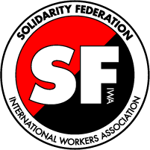
Contact us at: brighton@solfed.org.uk
or call 07561 185 204

