BENEFIT GIG
IN SOLIDARITY WITH ANARCHISTS AGAINST REPRESSION IN SPAIN
Sun 19 Apr 7pm, Banshee Labyrinth, Niddry Str, Edinburgh EH1 1LG

- to raise awareness about the repressive reforms such as Operación Pandora, Operación Piñata, Penal Code Reform (more anti-union laws) and Ley Mordaza (the Gag Law) which will attempt to criminalise working class self-organisation and self-defence in favour of capitalism and state coercion.

- to raise funds to help anarchist detainees with disproportionate bail costs.

NOT FOR FLYPOSTING | 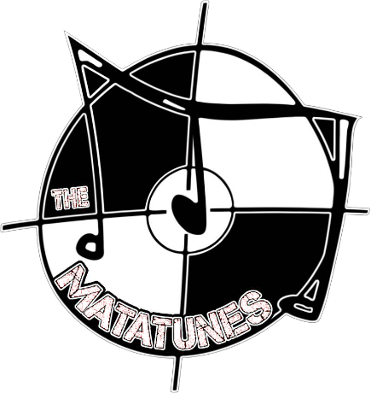  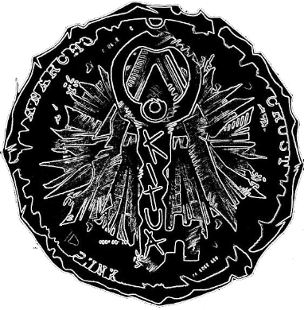 | * THE MATATUNES  Edinburgh, hardcore ska punk
* SHAREHOLDER
Edinburgh, unruly rock three-piece band
 |  | * KITUA  Edinburgh, anarcho crust punk | £5 entry donations welcome
 | Cinema (before the bands) between 7-8pm |  | 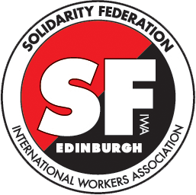edinburghsf@riseup.net www.solfed.org.uk  www.iwa-ait.org
Torturadxs (2006) 33 mins. theatrical short about repression, discrimination and police brutality.

L'Idee (1932) 25 mins. classic woodcut silent animation with english subtitles by Berthold Bartosch & Frans Masereel about the role of the church and state to enforce repression.
The films are followed by a short presentation by Solidarity Federation and friends before the bands. See our stall with publications on anarchism and anarcho-syndicalism in english, spanish, polish, etc

