Solidarity Protest
MEET: Spanish Consulate, 63 North Castle St, Edinburgh EH2 3LJ
FRIDAY 6 Feb – FROM 12:00noon
HARASSED! CHARGED! IMPRISONED! FOR BEING ANARCHISTS!
by ‘operación Pandora’ in Spain
‘Un movimiento que olvida a sus presos está condenado a la derrota’
‘A movement that forgets its prisoners is doomed to defeat’
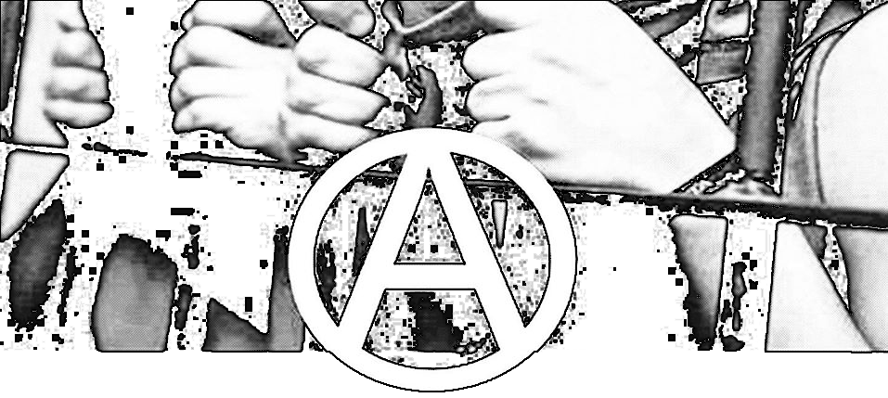

On 16/12/2014 Mossos d'Esquadra (Catalan “independent” police ‘squaddies’) stormed 14 homes and social centers in Barcelona and Madrid, destroying or stealing everything of value. Without concrete accusations and with the greatest secrecy, 11 anarchists (7 women and 4 men) were sent to a High Court in Madrid. 4 were released two days later with charges - and 7 stayed in prison until they were eventually released on extortionate bail of €3000 each on 30/01/2015, one is a member of the CNT-AIT Union. The anarchists continue to endure harassment, charges and secretive Court proceedings because of their criticism and opposition to capitalism and the state.
drop the charges!
_____________________________________________________________________________
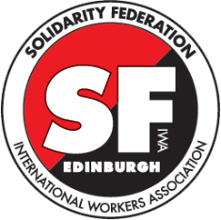
Edinburgh Solidarity Federation, c/o ACE, 17 West Montgomery Place,
Edinburgh EH5 7HA | edinburghsf@riseup.net | www.solfed.org.uk
International Workers’ Association, Targowa 22 lokal 27 a03-731
Warszawa, POLSKA | secretariado@iwa-ait.org | www.iwa-ait.org
further information: efectopandora.wordpress.com
the terrorist is
the capitalist state
‘Operación Pandora’ is a deliberate attempt to intimidate and criminalise the libertarian movement, which has been pursued by the Spanish Audiencia Nacional [a special unit of the judiciary to combat "terrorism"] and the Catalonian police. On December 16th 2014, round-ups, searches, and arrests were carried out at squats of the “Casa de la Montaña” district of Barcelona, at the libertarian San-Andres reading room, and the anarchist Poble-Sec reading room, as well as raids at many private homes. At the same time, several adjacent streets were blocked off and the district was cordoned off to the south to prevent access to a park. Hundreds of riot police took part in the operation. Searches and arrests were also conducted in Madrid.

All 11 detainees are anarchist activists (4 of them were released on December, 18th). One detainee is a member of the CNT union (from Sabadell) which is affiliated to the International Workers Association. Solicitors for the accused have stated that they have been arrested for being organised; evidence against the accused is non-existent and desperate. Presiding Judge Bermúdez said “I am not investigating specific acts, I am investigating the organization, and the threat they might pose in the future”.

‘Ley Mordaza’ (Gag Law) is an attack on dissent and protest in Spain. It passed the lower house of Spain's parliament and is due to be passed by the senate in February. It imposes harsh fines (of up to €30,000) for, among other things, demonstrations not officially state-approved, audio/video recording the police, and offending Spain, as well as allowing blacklisting of dissenting press, political and labour organisations.

There has been much talk recently about freedom of speech and freedom of association. There has also been much hypocrisy, such as the recent march in Paris, attended by Spanish PM Mariano Rajoy, meanwhile in Spain, the ruling PP (the inheritors of Francoism) have introduced the so-called ‘Gagging Laws’

We ask for solidarity. All that are able to hold protests against the repression - against ‘Operación Pandora’ and the ‘Ley Mordaza’ (Gag Law)
Stop repression in Spain!
_____________________________________________________________________________
Edinburgh Solidarity Federation, c/o ACE, 17 West Montgomery Place,
Edinburgh EH5 7HA | edinburghsf@riseup.net | www.solfed.org.uk
International Workers’ Association, Targowa 22 lokal 27 a03-731
Warszawa, POLSKA | secretariado@iwa-ait.org | www.iwa-ait.org
further information: efectopandora.wordpress.com

